Lancashire Skills and Employment Board

Private and Confidential: No

Date: 27th July 2016

Post-16 Skills Plan
Report Author: Dr Michele Lawty-Jones, Director of the Lancashire Skills Hub, michele.lawty-jones@lancashire.gov.uk

Executive Summary

The paper provides a brief summary of the 'Post-16 Skills Plan' white paper published by Government earlier this month. The paper articulates how the Government aims to introduce 15 new technical education routes, replacing the current post-16 classroom based vocational offer.
Alongside the paper, Paul Holme will provide a broader policy update at the meeting.
Recommendations
The Board is asked to consider the implications of the paper, alongside a verbal input from Paul Holme on the broader Skills Policy picture.

1. Post 16 Skills Plan

  - The post 16 skills plan was published earlier this month following the recommendations from the review led by Lord Sainsbury of technical education.

2. Main Points

2.1 Essentially the plan aims to streamline the current post-16 classroom based vocational offer into a common framework of 15 technical routes, grouping together occupations which have shared training requirements. This will create two choices post 16: the academic or technical option, with bridging courses between the two. The diagram overleaf provides a visual summary. The system also includes an optional transition year for individuals who are not ready to access a route at 16 (or older if their education has been delayed).

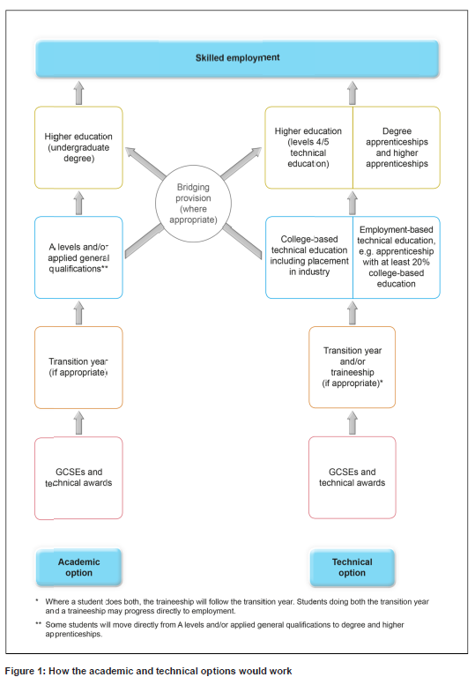
2.2 The plan aims to address the weaknesses in the UK's skills base which contributes to the ever-increasing productivity gap. The UK is forecast to fall from 22nd to 28th out of 33 OECD countries by 2020 on intermediate professional and technical skills. The plan aims to address this issue.

2.3 Employers will be at the heart of the design of the 15 new routes; the Institute of Apprenticeships will morph to the Institute of Apprenticeships and Technical Education and lead the development of an employer led system.

2.4 It is proposed that the Institute will convene panels of professionals for each route to advise on the knowledge, skills and behaviours that individuals will need to meet the standard in each route, and on suitable assessment strategies for classroom based learning. It is proposed that there will be one approved technical level qualification for each occupation or cluster of occupations within a route to avoid the current 'race to the bottom' in which awarding organisations compete to offer qualifications which are easier to pass and thus of lower value. A set of common transferable workplace skills will apply across all routes, as well as quality work placements.
2.5 There is reference to working with the Careers and Enterprise Company to support young people to make informed choices, and the development of a new tool for use by young people to help them make choices. The Careers Strategy, being developed in parallel, will outline how Careers Education, Information and Guidance will be taken forward.
2.6 The plan includes a timeline – it is anticipated that the reforms will be phased in progressively, with a small number of 'pathfinder routes' which will start to develop standards this year for delivery in 2019, with additional routes becoming available for teaching in phases between 2020 and 2022.
2.7 The list of the 15 proposed routes is provided in Appendix A.

Appendix A

